**Python exercise for if statements**

1. Question: Write a Python program to check if a number is even or odd without defining a function.

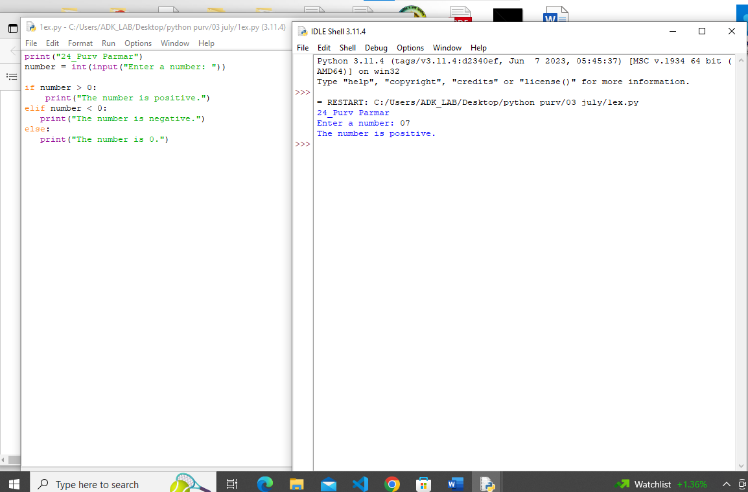

2. Question: Write a Python program to check if a number is positive or negative without defining a function.

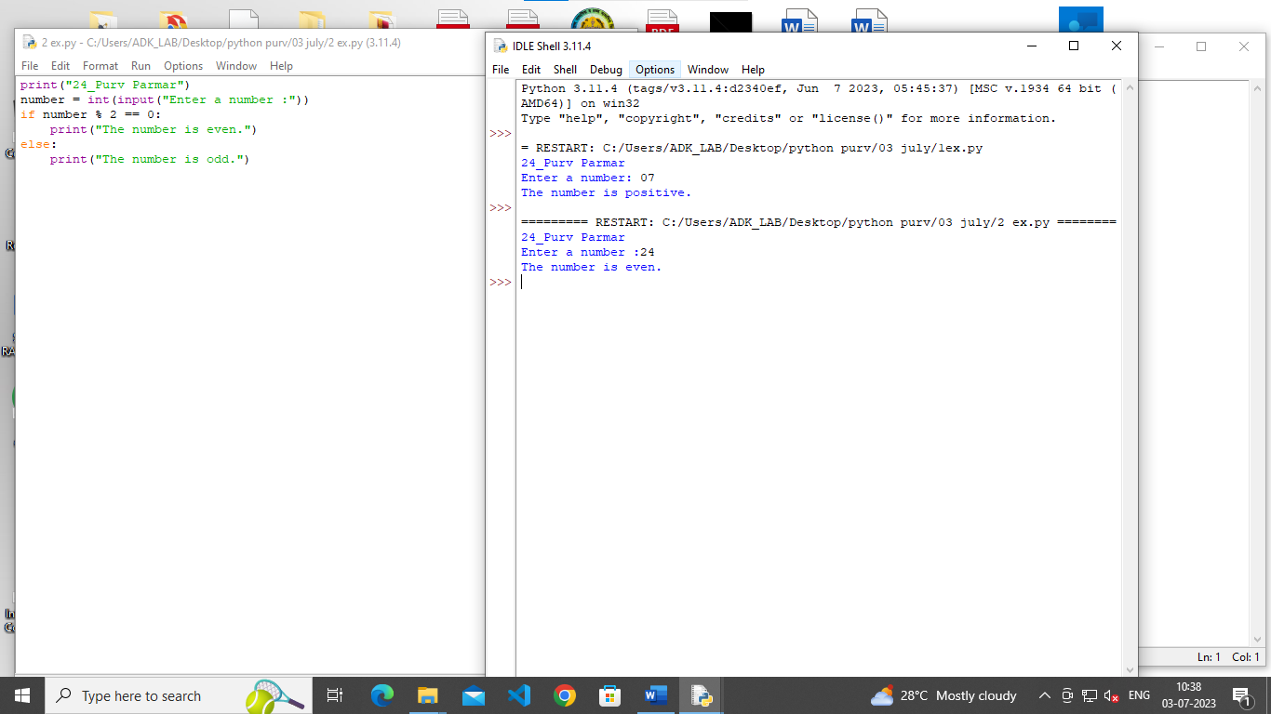

3. Question: Write a Python program to check if a year is a leap year without defining a function.

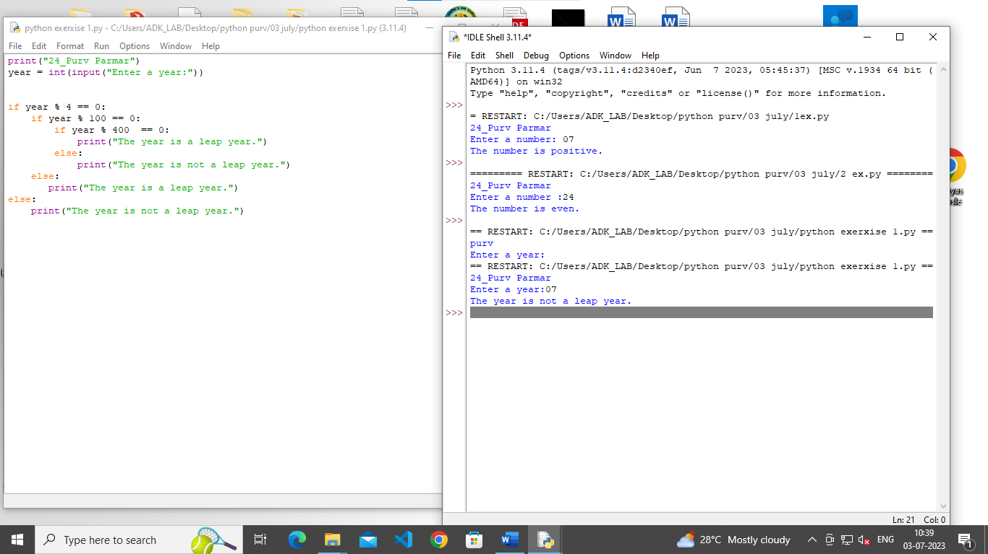

4. Question: Write a Python program to check if a string is a palindrome without defining a function.

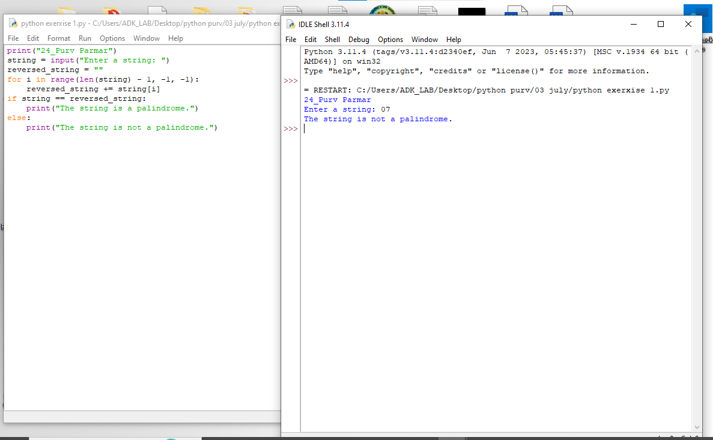

5. Question: Write a Python program to check if a number is prime without defining a function.

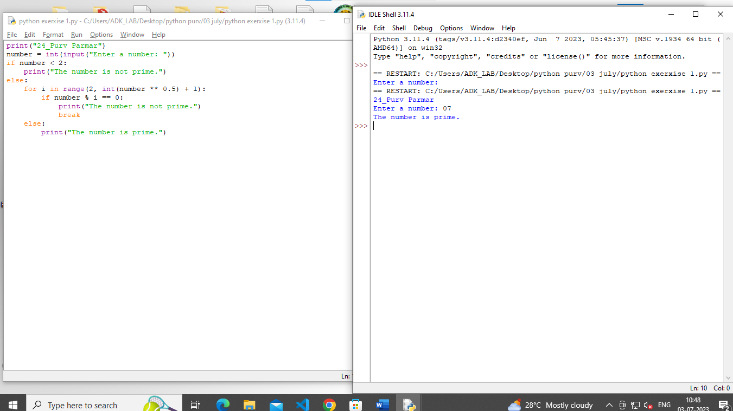

**Python exercise for Elif statements**

1. Question: Write a Python program to check if a number is even, odd, or neither using elif statements.

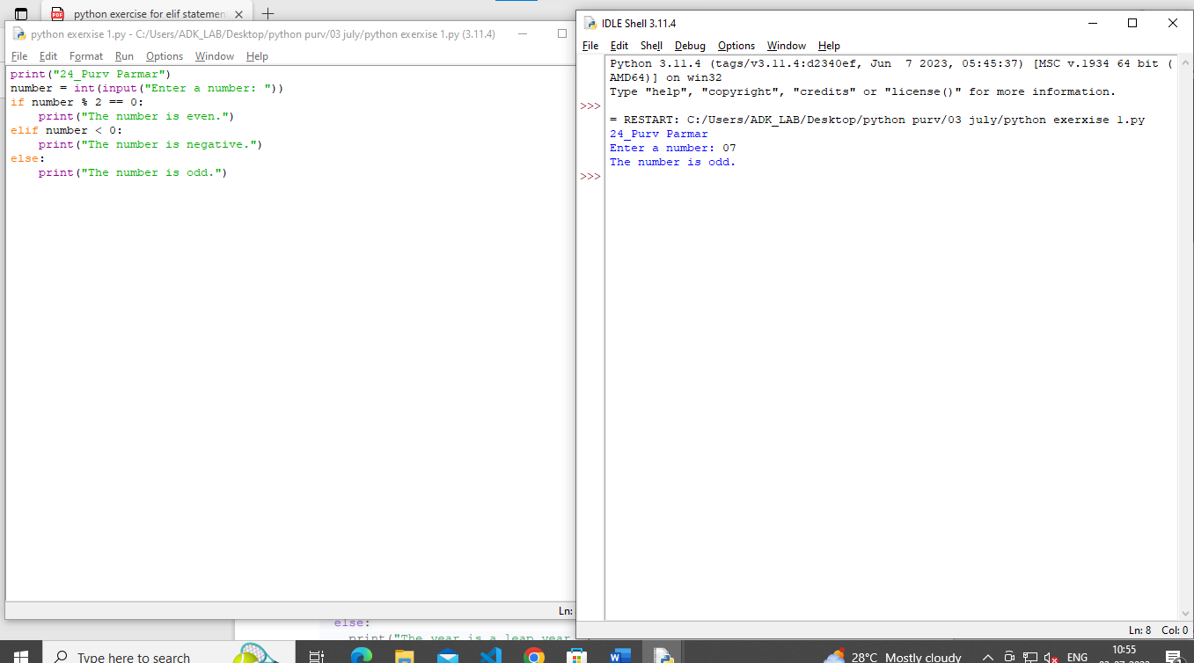

2. Question: Write a Python program to check if a year is a leap year, ordinary year, or century using elif statements.

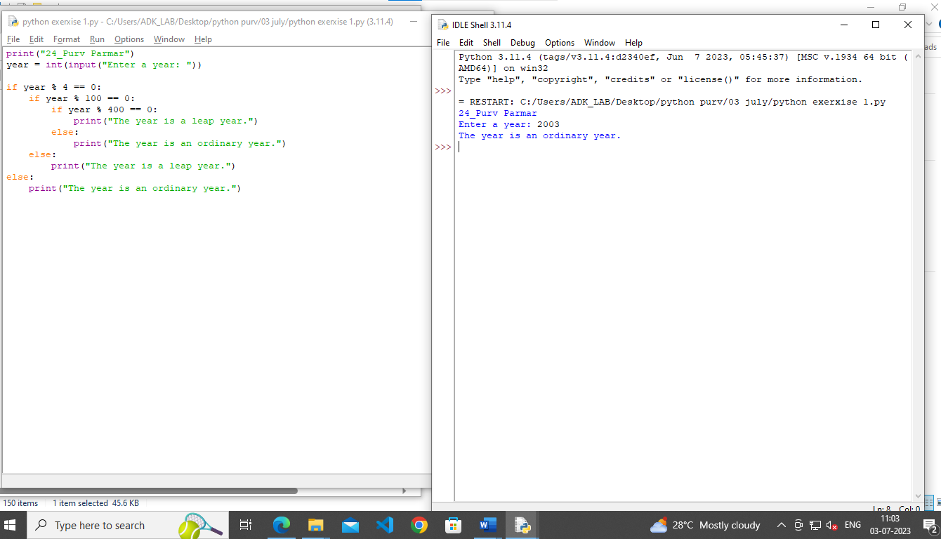

3. Question: Write a Python program to check if a string is a palindrome, a palindrome with vowels removed, or neither using elif statements.

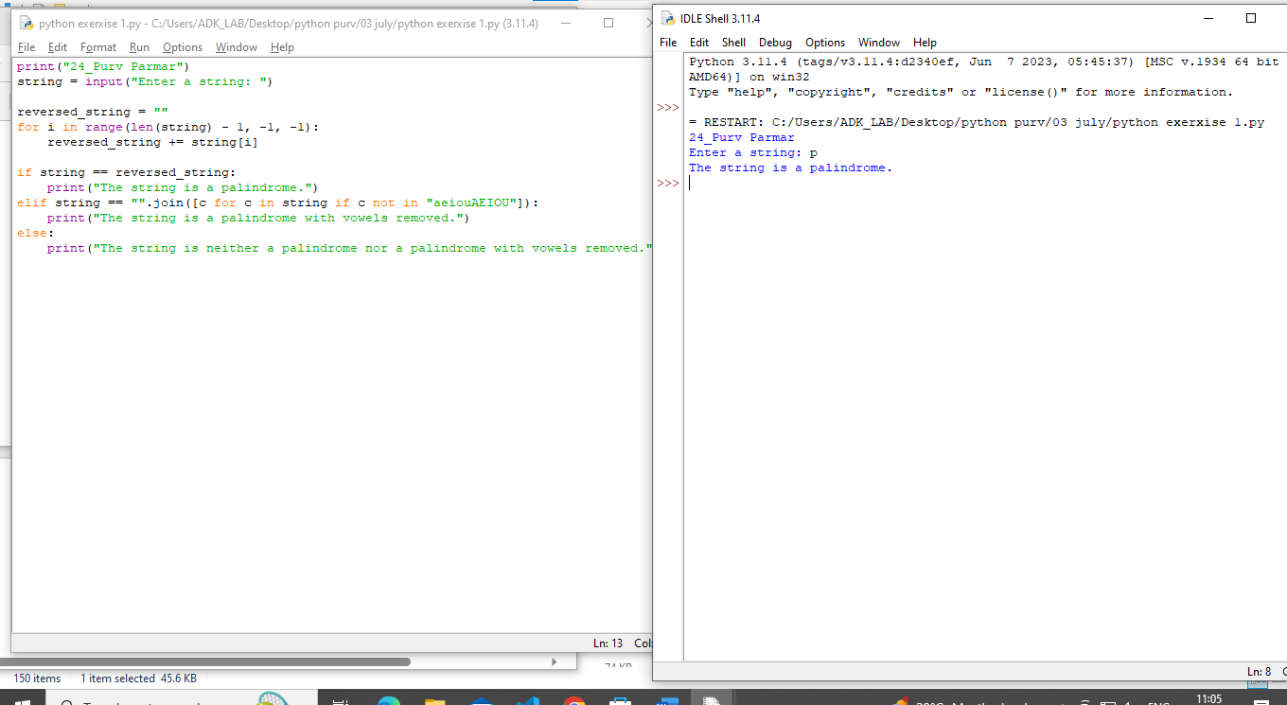

4. Question: Write a Python program to check if a number is prime, composite, or neither using elif statements.

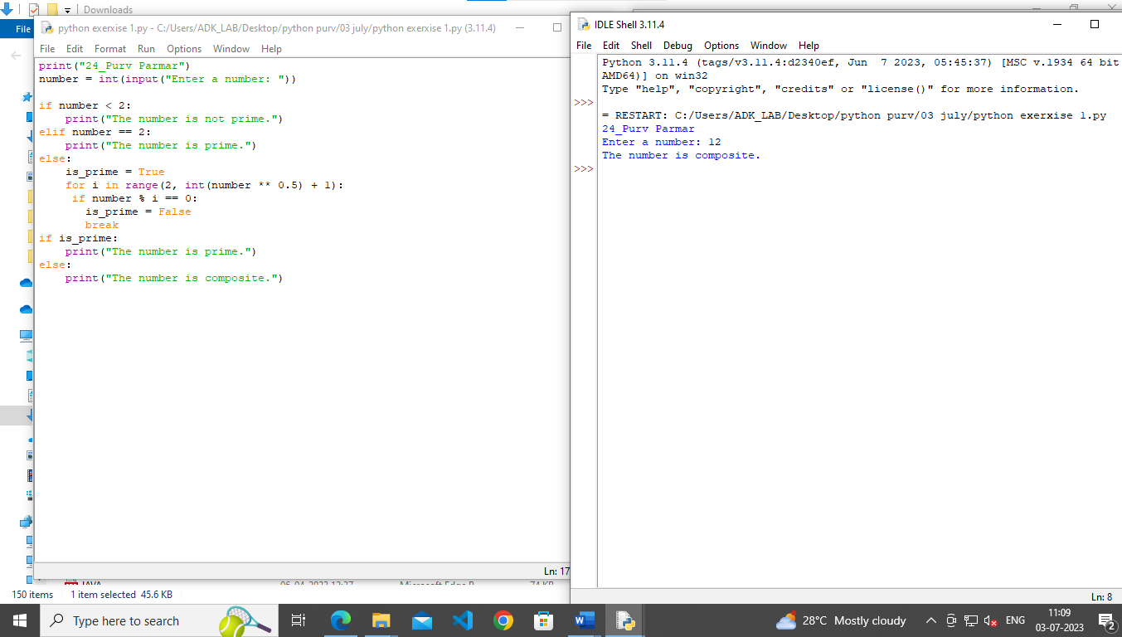

5. Question: Write a Python program to check if a number is positive, negative, or zero using elif statements.

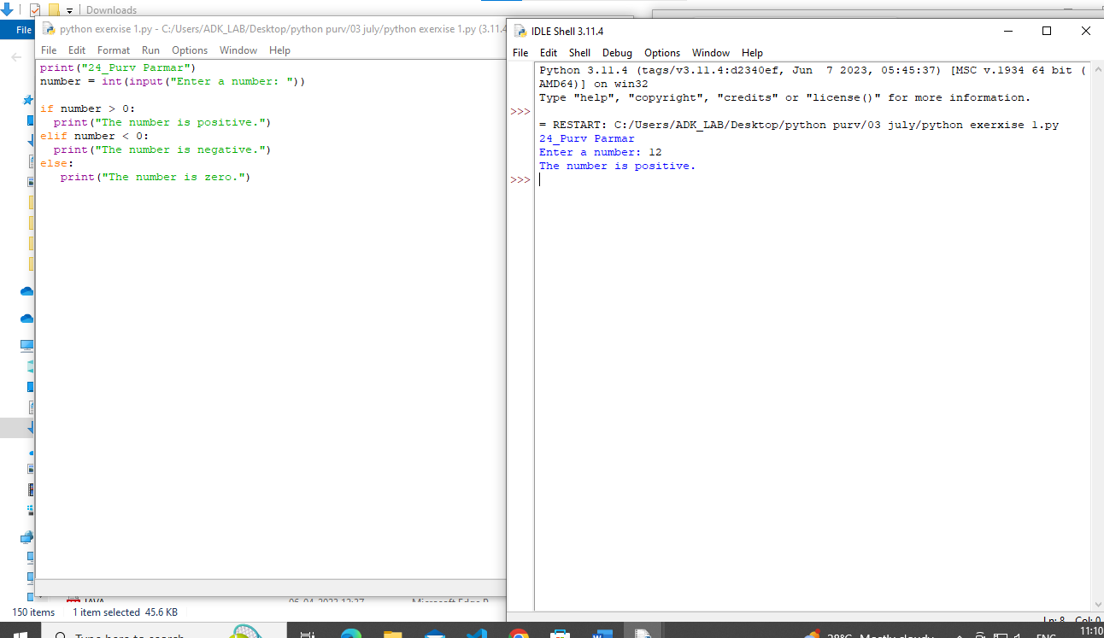

1. Question: Write a Python program to check if a number is even, odd, or divisible by 3 using nested if-else statements.

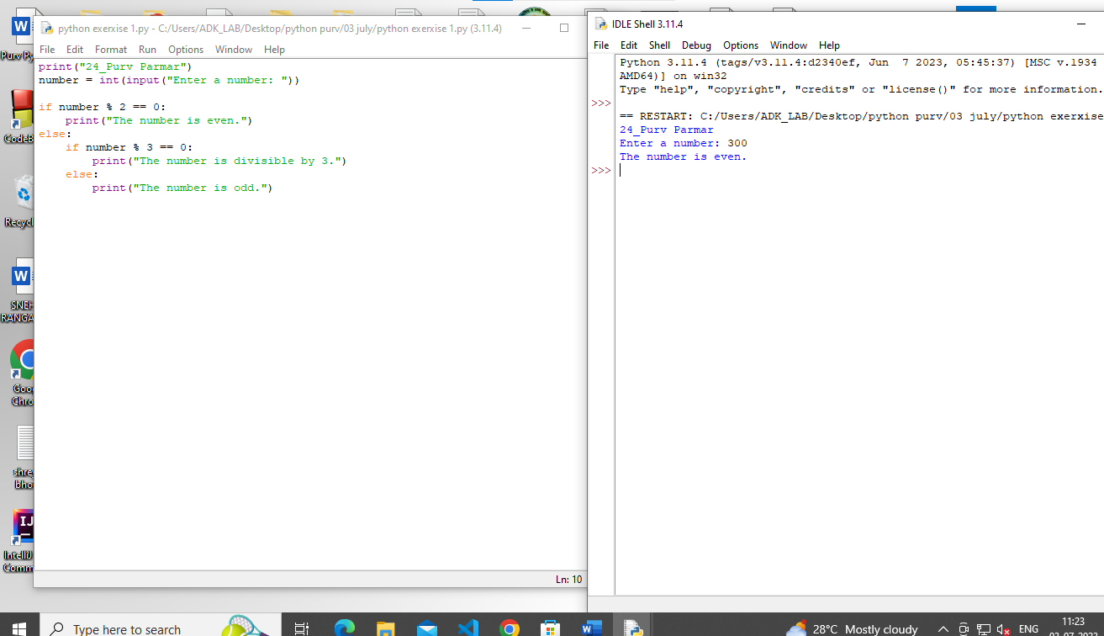

2. Question: Write a Python program to check if a year is a leap year, ordinary year, or century using nested if-else statements.

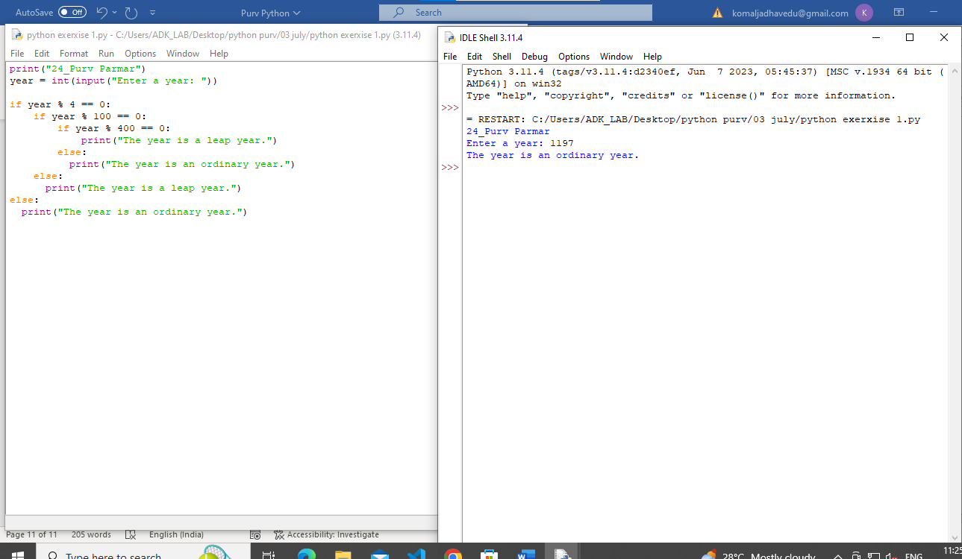

3. Question: Write a Python program to check if a string is a palindrome, a palindrome with vowels removed, or neither using nested if-else statements.

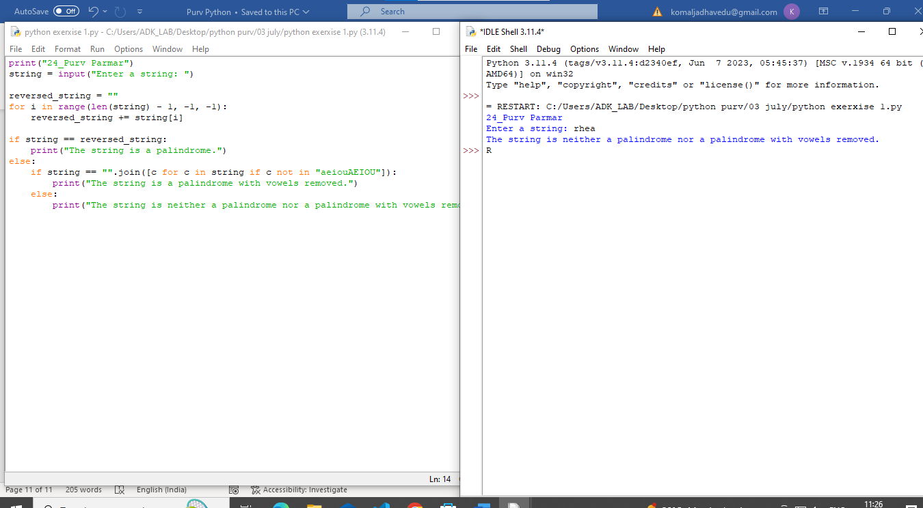

4. Question: Write a Python program to check if a number is prime, composite, or neither using nested if-else statements

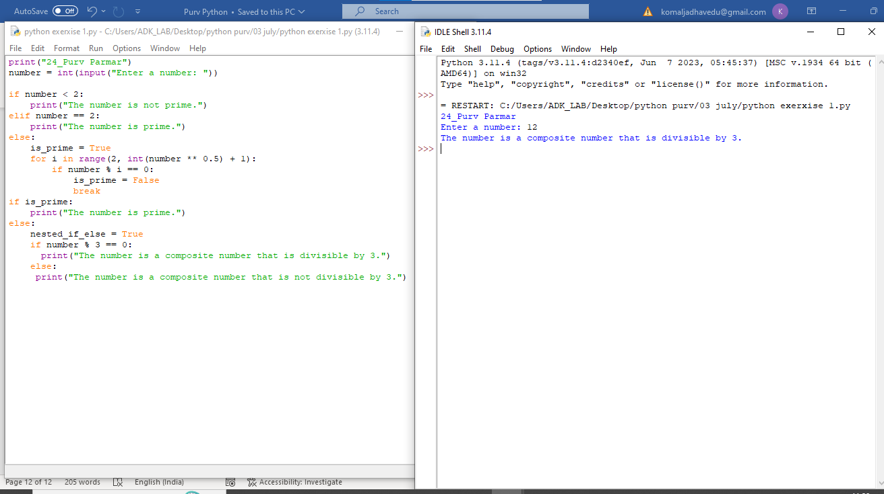

5. Question: Write a Python program to check if a number is positive, negative, zero, or even using nested if-else statements.

